A Day in My Life
By Vedin Muratovic

I normally wake up at 7:45, which gives me enough time to get ready for school, unless I am trying to go work out early in the morning, which means I wake up at 6:30 occasionally. | Brush my teeth, eat breakfast (Cinnamon Toast Crunch), and complete the rest of a normal person’s morning routine. | Dad drops me off at school every single morning right next to the gym entrance.
Go to through school and finish working In all 6 of my classes, my least favorite being AVID.  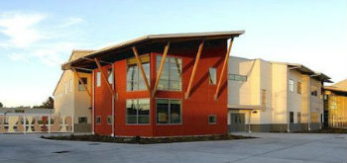 | Go and play soccer with a bunch of friends every single day at Wilson Playfield. | Play accordion as soon as I get home from playing soccer with my friends (go hard on the accordion and piano).
After I have a good chunk of fun after soccer and accordion, I have to do the most boring part of my day, homework. | Now this part of my day depends on how much homework I have. If I have too much I never get to do this but normally after I finish my homework I either watch Netflix or play Lol. | After a pretty interesting day I go to sleep around 12 or 12:30 because I cant fall asleep right away, I don’t know why.  